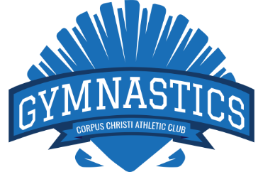
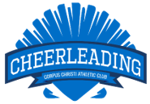
Corpus Christi Athletic Club
Gymnastics & Cheerleading
Class Schedule

 | MONDAY | TUESDAY | WEDNESDAY | THURSDAY | FRIDAY | SATURDAY
9:00am – 9:45am |  |  |  |  |  | Jumping Bunnies
10:00am -10:45am |  |  |  |  | Jumping Bunnies | Starfish – 4-5 yrs.
10:00am –10:55am |  |  |  |  |  | Beg. Gymnastics  Int. Gymnastics  Adv. Gymnastics  CHEERLEADING
11:00am -11:45am |  |  |  |  |  | Minnows 3 – 4yrs.
11:00am -11:55am |  |  |  |  |  | Beg. Tumbling  Int. Tumbling  Adv. Tumbling  CHEERLEADING
INVITE ONLY | Team Gymnastics | Team Gymnastics | Team Gymnastics | Team Gymnastics | Team Gymnastics | Team Gymnastics
4:30pm - 5:15pm | Starfish – 4-5 yrs. | Minnows –3-4 yrs. | Starfish – 4-5 yrs. | Minnows –3-4 yrs. | Starfish – 4-5 yrs.
4:30pm - 5:25pm | Beg. Gymnastics  Int. Gymnastics  Adv. Gymnastics | Beg. Tumbling  Int. Tumbling  Adv. Tumbling | Beg. Gymnastics  Int. Gymnastics  Adv. Gymnastics | Beg. Gymnastics  Int. Gymnastics  Adv. Gymnastics | Beg. Gymnastics  Int. Gymnastics  Adv. Gymnastics
5:30pm - 6 :15pm | Minnows –3-4 yrs. | Starfish – 4-5 yrs. | Minnows –3-4 yrs. | Starfish – 4-5 yrs. | Minnows –3-4 yrs.
5:30pm -6:25pm | Beg. Gymnastics  Int. Gymnastics  Adv. Gymnastics | Beg. Gymnastics  Int. Gymnastics  Adv. Gymnastics | Beg. Tumbling  Int. Tumbling  Adv. Tumbling | Beg. Gymnastics  Int. Gymnastics  Adv. Gymnastics | Beg. Tumbling  Int. Tumbling  Adv. Tumbling
6:30pm - 7:15pm | Starfish – 4-5 yrs. | Minnows –3-4yrs. | Starfish – 4-5 yrs. | Minnows –3-4 yrs. | Starfish – 4-5 yrs.
6:30pm - 7:25pm | Beg. Tumbling  Int. Tumbling  Adv. Tumbling | Beg. Gymnastics  Int. Gymnastics  Adv. Gymnastics | Beg. Gymnastics  Int. Gymnastics  Adv. Gymnastics | Beg. Tumbling  Int. Tumbling  Adv. Tumbling  CHEERLEADING | Beg. Gymnastics  Int. Gymnastics  Adv. Gymnastics
7:30pm - 8:25pm |  | Elite Tumbling | Adult Open Gym | Elite Tumbling | Open Gym
SET UP A FREE TRIAL CLASS TODAY!
For pricing and registration information contact the Gymnastics Team Leader.
Jade Gray | 361-992-7100 ext. 1225 | jgray@ccathleticclub.com

